A Quantitative approach to Religion and Economy: A study on   
 Maha kumbh 2025 **Abstract:**This study explores the intricate relationship between religion and economy through an in-depth quantitative analysis of the *Maha Kumbh* *Mela*, the world's largest religious gathering held in Prayagraj, India. Anchored in Hindu mythology, the *Maha Kumbh* attracts millions of pilgrims, ascetics, and tourists, creating significant socio-economic opportunities. The research examines how religious events function as economic catalysts by stimulating key sectors such as accommodation, transportation, and food services. It also assesses the impact of such mega religious events on different segments of societies i.e. marginalized(informal) and formal sectors. Regression analysis is used to quantify the relation between religion and economy and statistical analyses are employed to quantify the financial impact of the event. The findings indicate that Maha Kumbh contributes to substantial economic growth, fostering infrastructural development, revenue generation, and employment while also highlighting economic disparities and challenges in equitable benefit distribution.  
**Introduction:**  
The maha kumbh mela (the festival of the sacred pitchers) is anchored in hindu mythology. It is the world's largest public gathering and collective act of faith.The congregation primarily includes Ascetics,Saints,Sadhus,Sadhvis,Kalpavasis and pilgrims from all walks of life.  
The origins of the Kumbh Mela are rooted in Hindu mythology. According to the Samudra Manthan (churning of the ocean) story in the ancient Hindu scriptures, the gods (Devas) and demons (Asuras) fought over the Amrit (nectar of immortality). During this celestial battle, drops of the nectar fell at four locations—Prayagraj, Haridwar, Ujjain, and Nashik—where the Kumbh Mela is now held, with the Maha Kumbh occurring once every 144 years at Prayagraj. Historically, the Maha Kumbh Mela has been referenced since ancient times, with records dating back to the Maurya and Gupta periods.Over centuries, it evolved into a global spiritual and cultural phenomenon. Recognized by UNESCO as an intangible cultural heritage, the Kumbh Mela symbolizes India’s enduring traditions, fostering unity, spirituality, and cultural exchange among millions worldwide. The timing of each Kumbh Mela is determined by the astrological positions of the Sun, Moon, and Jupiter, believed to signal an auspicious period for spiritual cleansing and self-enlightenment. The festival embodies a confluence of faith, culture, and tradition, attracting ascetics, seekers, and devotees alike. The event’s grandeur is marked by Shahi Snans (bathing rituals), spiritual discourses, and vibrant cultural processions that reflect India’s deep spiritual heritage.  
The maha kumbh is about 2 months (specifically 45 days) long mega gathering event with more than 400 million pilgrims attending the *mela* providing immense opportunity for socio-economic development of Prayagraj.  
Previous researches on religion and economy seems to be very correct in the context of mahakumbh.**McCleary**(2007;2011) have concluded;   
 **Religion as an *independent variable*.The influence of religion on economic process is the central object of study: e.g. the influence of religious structure on interpretation of economic behaviour is researched ,especially religious attitudes toward inner worldly activities and rewards.**These statements are really valid in Indian context for pilgrimage tourism like *Maha kumbh.* Here a huge economic impact can be seen in the form of employment generation, infrastructure development & revenue generation.Every pilgrimage site including *Maha Kumbh* has an impact on three major and important sectors: Accommodation ,Transport and restaurants/food & beverages. These pilgrimages just not benefit the private business but all the people of that sacred complex and area around it.These kind of events lead to development of new infrastructures, renovation of old infrastructure to facilitate the pilgrims . For better hospitality of pilgrims, a neat & clean environment is maintained with enhancement in waste management systems and security etc. As all these are public good so they are ***non-excludable*** and ***nonrival*** so benefitting all the society.  
As Maha Kumbh is about 2 month long mega events there is a huge opportunity for small business, vendors to local artisan to big businesses and hotel owners to grow their business and inducing an economic boost.  
McCleary(2007;2011) have also concluded;   
 **Religion as a dependent variable.The influence of economic circumstances on religion-e.g. variances in religious supply and demand -is studied using market and choice models as well as institutional analysis of religious environments.**The current economy of india is competing with GDP growth rate of many developed economies so we can conclude that there is push factor by economy circumstances rather than pull factor for pilgrimage tourism as better economic condition gave state confidence to promote cultures and use them as soft power at national and international level.Also the politicization of religion has a huge impact on creating a good *economy* for religion.  
 However, the relation between economy and religion is bidirectional. Religion induces economic boost for the sacred complexes, area around it and also for the people connected with it while economy circumstances decides the dissemination of religion *ceteris paribus.*This can be validated by examining the data of kumbh 2019 in which 4200 crore was allotted which result not only in financial growth of private companies,vendors or contractor but government had also accumulated huge revenue whose statistics are given below:  
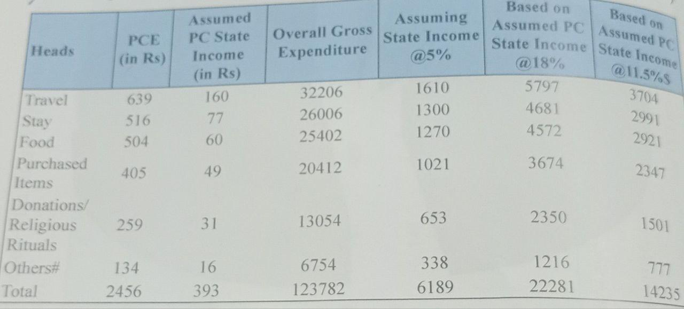  
SOURCE: *Field Survey GBPSSI,Jan-Feb 2019   
#Structure is obtained from a paper Assessing the kumbh economy by Bhatt.*This study is mainly focused on quantifying the relation between economy and religion. It will also try to measure the financial impact of maha kumbh on various sectors and marginalized populations. Along with this it will also analyze the informal economic activities which are created due to maha kumbh and major economic problems because of this mega event.  
This study can be seen as the epitome of interdisciplinary approach to anthropology. In this study we will find how economics is related to anthropology. This study highlights the importance of economics in social and cultural practices and vice versa.It tells us how cultural dissemination depends upon the economy and how the economy is affected due to these cultural practices.  
**Literature review:  
- *Spirit of capitalism: Religion and economic development*** In this research paper, Barro argued that successful explanations of economic performance have to go beyond narrow economic variables to encompass political and social forces.It indicates economic influence of religion has a profound impact on economic performance.Religion influence the formation of belief that shape individual traits ]such as honesty, work ethic, thrift and openness to strangers.Religious beliefs and related character traits can be seen as "spiritual capital," a concept that is analogous to the human capital that economists have found to be important for worker productivity.spiritual capital includes formal education through organized religion, as well as influences from family and social interactions. Thus, the economic effects of organized religion can be seen as operating through the formation of spiritual capital.  
The relationship between religion and economic growth becomes clear when measures of religiosity are incorporated into more traditional cross-country data sets on national-accounts variables and other economic, political, and social indicators observed since 1960. The measures of participation in organized religion and of religious beliefs come from representative surveys of individuals in about 60 countries, such as the World Values Surveys,International Social Survey Program, and Gallup Millennium Survey.   
The results of such studies have consistently found that religious beliefs profoundly influence economic growth. For example, for given levels of church attendance, economic growth rises when certain religious beliefs increase. The beliefs that seem to be growth promoting are those concerned with hell, heaven, and an afterlife.Convictions such as a belief in heaven or hell might affect individuals by creating perceived punishments and rewards that relate to "good" and "bad" lifetime behavior- which in turn can influence behaviors like thrift, work ethic, and honesty that contribute to economic growth. But these values must come from somewhere in the first place.Thus, if we assume that religious beliefs are fixed- as we do in our empirical work- an increase in attendance at houses of worship signifies that the religion sector is less productive.That is, more resources, in terms of time and goods, are being consumed by the religion sector for given outputs (the religious beliefs). Hence, the negative relationship between

attendance at houses of worship and economic growth.A graphical representation from the paper is given below:  
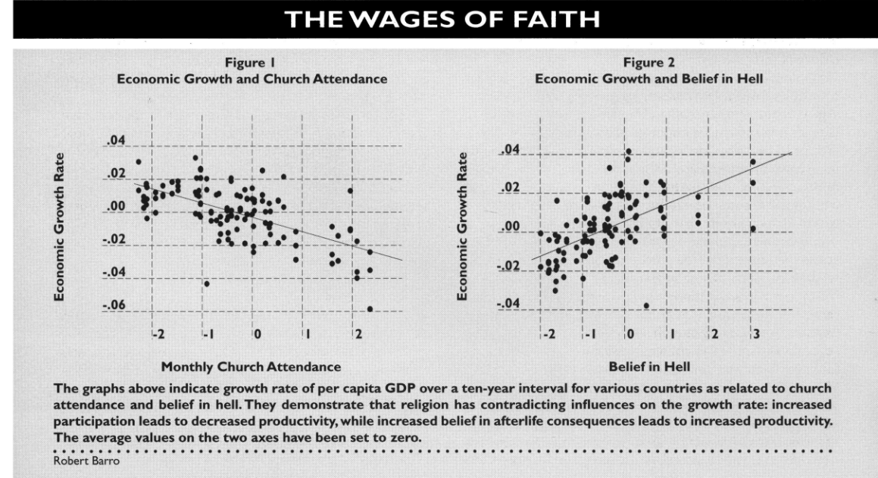

However, this kind of relationship seems very unscientific and more focused on the behavioral impact of religion and its relation with economic performance.It might not represent the direct relation between economy and religion. So in our study we will try to run a regression analysis for quantification of relation between economy and religion.

***-The Desecularization of the World: Resurgent Religion and World Politics***

In *The Desecularization of the World: Resurgent Religion and World Politics* (1999), Peter L. Berger challenges the once-dominant secularization hypothesis by documenting the global resurgence of religious movements. Berger, who had been a major early proponent of secularization theory, openly acknowledges that the prediction of religion’s inevitable decline with modernization has not materialized universally. Instead, he and the contributors to this volume argue that religious belief and practice have remained vibrant — and in many contexts, have even strengthened — despite, and sometimes because of, processes of modernization and globalization.  
It is a collection of essays from scholars focusing on different regions, including Latin America, the Muslim world, Russia, India, China, and the United States. Berger frames the introduction and conclusion, providing a theoretical context for understanding why secularization did not occur in the sweeping, global manner that early theorists like Max Weber or himself once predicted. He argues that while secularization may be evident in specific places — particularly in Western Europe — it is not a global phenomenon. Instead, much of the world is witnessing a "desecularization," where religious institutions, practices, and worldviews have reasserted themselves in both public and private life.  
A key theme in the volume is the idea that modernization does not necessarily undermine religion. In many cases, it provides the tools and networks for religious movements to flourish. For example, Pentecostalism's explosive growth in Latin America and parts of Africa shows how modern communication and urban migration have aided religious revival. Similarly, in the Islamic world, modernization and globalization have been accompanied not by secularization, but by Islamic revivalism, often linked to political movements. The case studies in the book demonstrate that rather than being eroded by economic development, religion has adapted, diversified, and in many cases, has become an even more influential force in shaping political identities and public policies.  
Berger's analysis highlights several reasons for the persistence and resurgence of religion. One important factor is the human need for meaning, especially in times of rapid social change and existential uncertainty. Another is the role of religion in constructing group identities, particularly in contexts of political instability or cultural fragmentation. The book also emphasizes that religious resurgence is not always conservative; in some cases, it aligns with progressive or liberationist agendas, complicating any simplistic association between religion and traditionalism.  
One of the strengths of *The Desecularization of the World* is its regional diversity, offering a nuanced view of how religious resurgence manifests differently depending on historical, cultural, and political contexts. However, the volume also acknowledges that secularization is not entirely absent. In Western Europe, for instance, traditional religious practice continues to decline, though even there, new forms of spirituality are emerging outside institutional frameworks. Thus, Berger suggests moving away from grand narratives of inevitable secularization toward more context-sensitive analyses of religion's place in the modern world.

**-*A Survey on the Socio-Economic Dynamics of Kalpvasis[The Religious Campers] of Kumbh Mela 2019, Prayagraj,India: With Special Reference to Sanitation***This study focuses on social and economic dynamics of Kumbh 2019.Primary data was collected through a survey on Kalpvasis. For the survey, Questionnaire was made based on the different issues related to sanitation and demography of kalpvasis.Secondary source has been collected through visiting the websites, reports, collecting different articles to gain the knowledge within the topic.SPSS software was used to analyse the data.  
The major findings of this study are that the majority of the kalpvasis i.e. 31.6% belong to the income group Rs. 5000- Rs. 25000 and very few of the people doing kalpwas i.e. 3.2% who have income more than 50000. This data depicts that most of the *kalpvasis* belong to middle class families. It also found that popularity of Kumbh festival is more in people from unorganised sector and The majority of the *kalpavasis* (Approx 64.21%) spent money during kumbh mela is from Rs 10,001 to Rs 25,000.17.89% *kalpvasis* spent money approx. Rs 5001 to Rs. 10,000. Only a few people have spent less than Rs 2000. And only 12.63% of the kalpavis spent money More than Rs. 25000. This reflects a fair economic strata of people who joined kumbh mela.  
  
 **Research and Methodology:**This study can be seen as the epitome of interdisciplinary approach to anthropology. This study highlights the importance of economics in social and cultural practices and vice versa.It tells us how cultural dissemination depends upon the economy and how the economy is affected due to these cultural practices.This study is mainly focused on quantifying the relation between economy and religion with the help of regression analysis.It will also try to measure the financial impact of maha kumbh on marginalized populations.The study aims to quantify the direct economic effects while also capturing the qualitative experiences of marginalized sections and various participants of Maha kumbh.  
The research involves two types of research design i.e. correlational research design and descriptive research design. The two designs that are used are for different purposes. This research uses correlational research design for understanding relation between religion and economics while the latter one is used for assessing the impact of religion on marginalized sections and other participants of kumbh.  
**Correlational research design** is a quantitative research method used to examine the relationship between two or more variables without manipulating them. It aims to determine whether changes in one variable correspond to changes in another. However, it does not establish causation. This is the best quantitative method for our objective as it allows analysis of association between variables. Karl Pearson’s correlation is used to analyze the strength and direction of the relationship between religion and economy.  
Along with correlational analysis, **regression analysis** is used to quantify the relationship between religion and economy, specifically examining how religious events like Kumbh Mela impact local economic activities.This statistical method helps in understanding the strength and direction of the relationship between religious participation and economic outcomes such as income.Regression analysis is suitable for this research because:  
**1**.It helps establish causal or correlational relationships between religious activities and economic indicators.  
**2**. It quantifies the impact of religious tourism on local businesses, employment rates, and revenue generation.  
**3**.It controls external variables such as seasonal economic fluctuations and demographic factors, ensuring more accurate results.  
Variables in the Regression Model  
Independent Variable (IV): Expenditure by government on kumbh.  
Dependent Variables (DV): State revenue from kumbh.  
Control Variables**:** inflation, other macroeconomic variables.  
  
Choosing Expenditure as an independent variable is based on assumption that more the religious devotion of the population more will be the state expense to manage and facilitate these mega events. This also allows us to get accurate data as it will use data from government archival records.Dependent variable is chosen as state revenue unlike Baro who uses gdp growth as a dependent variable.This will help to mitigate the effect of other macroeconomic variables which can affect gdp growth and only measure the effect of religion.  
Data related to state expenditure and revenue from the previous organisation of kumbh is collected from the government portal of archival record.To include the inflation factor this study uses present value of previous expenditure and revenue.  
Furthermore ,**Google sheets** will be used to analyze the data graphically with the help of scatter plot and column charts.  
 **Data collection :**For primary data collection ,an Interview schedule is used. The reason is that the participants of the research vary tremendously in terms of literacy. Many of them may not be in school for a single day and many of them are highly educated.Verbal Interviews are also used for uncovering the problems which arise due to these mega events. The data is gathered through an interview schedule conducted with participants directly affected by Kumbh Mela 2025. Respondents include:

* Street vendors(Small/large)
* Marginalised section

The questionnaire comprises **close-ended and open-ended questions** to gather quantitative and qualitative data regarding business performance, challenges, and suggestions for improvement.The questions of the questionnaire is given below**:**

* Name: _________
* Type of Business: _________
* How did the number of customers during Kumbh Mela 2025 compare to a regular period?  
  + Much higher
  + Higher
  + About the same
  + Lower

Please estimate the average daily revenue on regular days (in INR):

* Please estimate the average daily revenue during Kumbh Mela 2025 (in INR):

These questions will provide deep insight into the effect of kumbh on the economics of people i.e. how their income and revenue increased. The open ended questions are used to enhance the accuracy and precision of the study because the effect of kumbh on income varies tremendously in different groups the questionnaire also have some other important question which is relevant to our study are given below:  
  
 What were the main challenges your business faced? (Select all that apply)

High competition  
Supply chain issues  
Lack of infrastructure  
Other: _________

What improvements would you suggest for future Kumbh Mela events to better support vendors? (Open-ended)

These questions are helpful for understanding challenges faced by different groups and provide a normative perspective to our study.This helps the government and administrator in organizing such mega events in future.  
  
The secondary data is majorly collected from government portals for Kumbh and other information disseminating agencies so that authenticity is maintained.These news disseminating government websites provide plenty of data for assessing the government expenditure on various aspects (from infrastructure to security to cultural promotion). These and Data for measuring association between religion and economy was gathered from the Department of culture of Uttar Pradesh which had their camp at Kumbh.Apart from that other major sources are earlier research papers on this topic. Some latest articles from national newspapers and latest research papers are also referred for deep understanding and more reliability.  
 **Area and participants:**This research is a perfect example of bounded research. Bounded research refers to a study that is limited in scope, time, population, or geographic area to ensure a focused and manageable investigation. In anthropology, bounded research helps in conducting an in-depth analysis of a specific cultural, social, or economic phenomenon without making broad generalizations.  
For this study on religion and economy, a bounded research approach is essential to maintain clarity and feasibility. Instead of examining religious-economic interactions globally, this research is limited to:

**-A Specific Event:** Kumbh Mela 2025  
**-A Defined Population**: Vendors, Worker, transport sector workers at kumbh  
-**A Set Time Frame**: 12 days ( from 07/02/2025 to 19/02/2025 ).  
**-A Geographic Location:**  
The Mahakumbh Mela is a temporary megacity that emerges during the festival period. Defining the research area, therefore, requires careful consideration of its dynamic and expansive nature. For this study, the research area is primarily defined by the officially demarcated boundaries of the Mahakumbh Mela 2025, as designated by the event authorities. These boundaries typically encompass:

* **The Mela Ground:** The core area where the majority of the religious activities, temporary settlements, and commercial activities are concentrated. This includes the extensive network of ghats (riverfront steps) along the sacred river, where the ritual bathing takes place; the sprawling tent cities that house pilgrims; and the various zones allocated for different religious sects, cultural performances, and administrative functions.
* **Ancillary Zones:** Areas immediately adjacent to the Mela Ground that are significantly impacted by the event. These may include transportation hubs (bus terminals, railway stations), extended accommodation areas, and key access routes used by pilgrims.  
  To be more precise with geographic location this research is mostly to collect data in a specified area constructed by the government. They call it sectors as they divide a huge area on the bank of rivers as sectors for better administration and facilitation.The government has divided the whole *mela kshetra* in 28 sectors and each sector is interconnected with pontoon bridges.

This delineation acknowledges the fluid nature of the event, where the concentration of people and activities may vary across time and space. While the primary focus remains on the Mela Ground, the study also recognizes the importance of the surrounding areas in understanding the broader socio-economic dynamics of the Mahakumbh.  
Map of the bounded area is given below:  
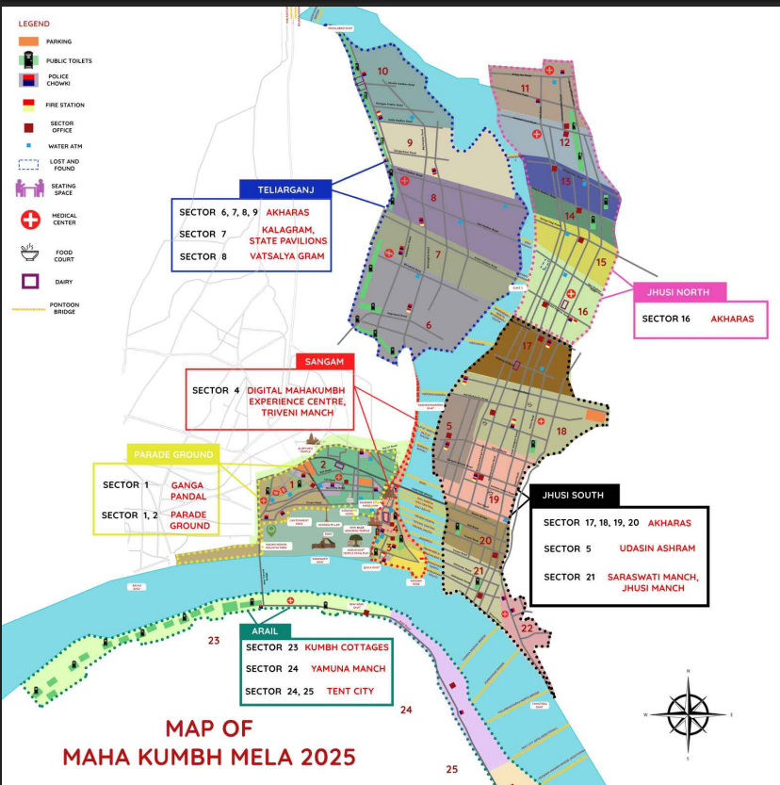 Credit: *indianculture.gov.in*  **Methodological Issues in Data Collection:**Conducting research on the intersection of religion and economy, particularly in the context of Kumbh Mela, presents several methodological challenges. These issues can affect the accuracy, reliability, and ethical integrity of the data collection process. Below are the key challenges and how they impact the research:

### 1. Access to Participants

* Challenge: Engaging with local vendors, pilgrims, and service providers during a large-scale event like Kumbh Mela can be difficult due to time constraints and their busy schedules.
* Impact: Many potential respondents may be reluctant to participate due to the pressures of their economic activities.In the field there are many incidents. I have to wait for 10-15 minutes to collect data from vendors. Also after asking 2-3 questions, the interview is interrupted due to customers.Sometime i have to leave the interview in between when a cluster of customers visit the shops.
* Solution: Using short, structured interviews and participant observation can help minimize disruption while gathering valuable insights.

### 2. Reliability of Self-Reported Data

* Challenge: Respondents may exaggerate or underreport their earnings, expenses, or the economic impact of the event.
* Impact: This can lead to inaccurate conclusions about the financial benefits or challenges associated with the religious gathering. I have felt that people are lying about their income as in the same area the rickshaw pullers have reported very different data like one rickshaw puller earns 2500-3000 and other one is reported 1200-1500. This is not just limited to rickshaw pullers, even vendors are reporting very different earnings in the same area having the same size of shops.
* Solution: Cross-verifying self-reported data with observational methods and secondary data sources (such as government or tourism reports) can enhance reliability.This is the major methodological issue and to counter it the study uses averages to make the data more accurate. This study gathers data from 3 participants of similar nature and then averaging it out so that the effect of extremeness can be mitigated.

### 3. Ethical Concerns and Sensitivity of the Topic

* Challenge: Religion is a deeply personal and sensitive subject. Discussing the economic aspects of religious events may be perceived as controversial or disrespectful by some participants.
* Impact: Some individuals may refuse to participate or provide socially desirable responses instead of honest opinions.Such an encounter was with a *thele wala* who is transporting people on his *thela.* On asking how much money he is making in a day, he replied ‘’*ham to unya kama rhe hai bhakto ki sewa kaike*“. I also replied sarcastically, ‘*meri bhi sewa krdo or chodh do chungi tak free me*”.
* Solution: Ensuring informed consent, cultural sensitivity, and using neutral, non-judgmental language can help build trust and encourage openness.  
    
  4. Logistical and Environmental Constraints
* Challenge: The temporary nature of the event, overcrowding, and environmental factors (such as weather conditions and sanitation issues) can hinder data collection.

Impact: Difficulty in setting up interviews, maintaining field notes. Also we are not allowed to visit the field on *shahi snans* which creates a void in our data. There is so much dust in the air that after my 1st day at the field I have a runny nose and coughing.Due to this I was unable to do my fieldwork properly for the next two days.  
Solution: Planning data collection during off-peak hours, carrying backup recording tools, and using paper-based interview schedules when necessary can mitigate these challenges.

5. Participation of intended subjects • Challenge: One key challenge in data collection is that many participants hesitate to disclose their income due to concerns about taxation, legal status, or government scrutiny. Informal vendors and service providers at Kumbh Mela often operate without proper registration or permits, making them wary of potential repercussions  
Solution: To overcome this rapport is established and assurance of anonymity of the participant is done. **Quantification of relation between Religion and Economy**Religion and economy are deeply interconnected, influencing each other in various ways across cultures and historical periods. Religious institutions often play a significant economic role through ownership of land, collection of donations, and organization of large-scale events like pilgrimages and festivals, which generate substantial revenue and employment. For instance, events such as the Kumbh Mela not only hold spiritual significance but also stimulate local economies by boosting tourism, hospitality, transportation, and small-scale trade. Pilgrimages attract millions of visitors, creating demand for food, accommodation, souvenirs, and religious paraphernalia, thus contributing to regional development.  
Furthermore, religion often shapes economic behavior and values. Ethical principles derived from religious teachings can influence how individuals approach wealth, charity, consumption, and work. Concepts such as zakat in Islam, daan in Hinduism, and tithing in Christianity highlight the role of religious obligations in wealth redistribution and social welfare. Additionally, religious institutions can act as economic actors themselves, managing large trusts, educational institutions, hospitals, and charitable organizations. This intertwining of religion and economy can also lead to the commercialization of religion, where spiritual practices are commodified, and religious events become opportunities for profit-making.  
The commercialisation of religion refers to the transformation of religious beliefs, practices, and spaces into commodities for economic gain. In contemporary society, religion is increasingly entangled with market dynamics, leading to the packaging and selling of spirituality in various forms—ranging from religious tourism and merchandise to paid rituals, televangelism, and digital devotion apps.

One major area of commercialisation is religious tourism. Pilgrimages like the Kumbh Mela in India or Hajj in Saudi Arabia have become not only spiritual journeys but also massive economic events. The Kumbh Mela, for instance, involves large-scale infrastructure investment, generates revenue for local businesses, and creates temporary employment. While these developments boost the economy, critics argue that they also shift the focus from devotion to profit-making ventures. As The religious space becomes an economic zone, the devotee is transformed into a consumer.  
To scientifically measure the extent of direct association between religion and economy, this study uses Karl earsons correlation coefficient to measure relation between state expenditure and revenue. Taking state expenditure as a determinant of extent of religiosity is based on “market’’ or “supply side’’ approach to religion.This approach suggests extent of religious diversity depends on the state and religion provider.**Barro and McCleary (2003)** argued that subsidies by state like payment to church employees, buildings encourage formal religious activity. The point is that, through subsidies, a state religion might have a positive effect on religious participation.   
This study assumes state revenue from the religious event(mahakumbh) as a measure of the economic effect of religion. Not taking gdp growth of a country as a parameter to measure the effect of religion like Baro so that we can mitigate the extraneous effect of other macroeconomic variables.State revenue is relatively better than any other variable to measure economic effect of religion as it will measure *Direct effect* and have *lesser extraneous effect.*This study uses historical data related to state expenditure and revenue from previously organized kumbh.We will first find present values of all the expenditure and revenue of the state so that we can account for inflation and Data is obtained from archival records of cultural department of uttar pradesh so that authenticity is also ensured. The raw data is given below which is then accounted for inflation factor:   
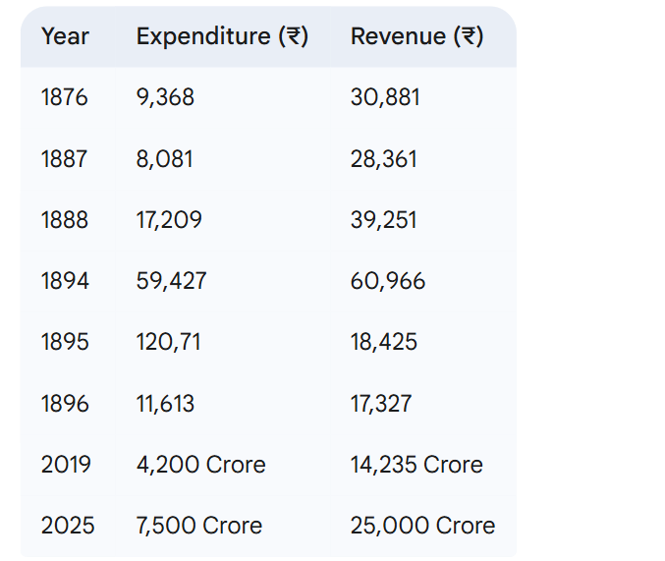**Table No. 2:**Showing raw data related to expenditure and revenue  
To find the future values of expenditure and revenue for all the given years, we need to project these values to a future point in time. Let's choose a future year for this projection. Since the latest year in the data is 2025, let's project all values to a common future year i.e. 2025.To do this,we need a growth rate. For economic data like expenditure and revenue, a reasonable growth rate to consider is the average inflation rate. Let's use an assumed average inflation rate of 5% (or 0.05) per year for our future value calculations.  
The formula for future value (FV) is: *FV*=*PV*×(1+*g*)^n  
where,

* FV is the future value
* PV is the present value (expenditure or revenue in a specific year)
* g is the growth rate (inflation rate in this case)
* n is the number of years between the present value year and the future year(2025)

**Data after accounting for inflation factor given below:**Let X denotes FV of Expenditure at year 2025 and Y denotes FV of Revenue at year 2025. 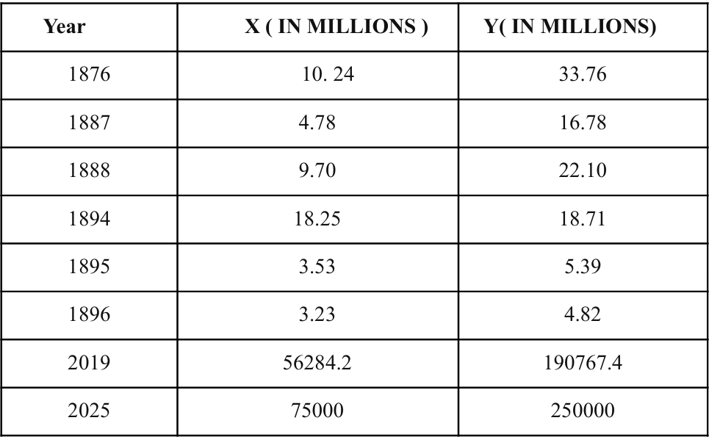 **Table no. 3:** Showing inflation adjusted state expenditure and state revenue  
 Now to measure the extent of association between religion and economy we use Karl Pearson’s   
correlation coefficient.  
Formula for the correlation coefficient(r) is :  **rxy = CoV(x,y)/Sx*Sy** Here,CoV(x,y) denotes covariance between x andY  
 And Sx is standard deviation of X,  
 While, Sy is standard deviation of  **Now,  
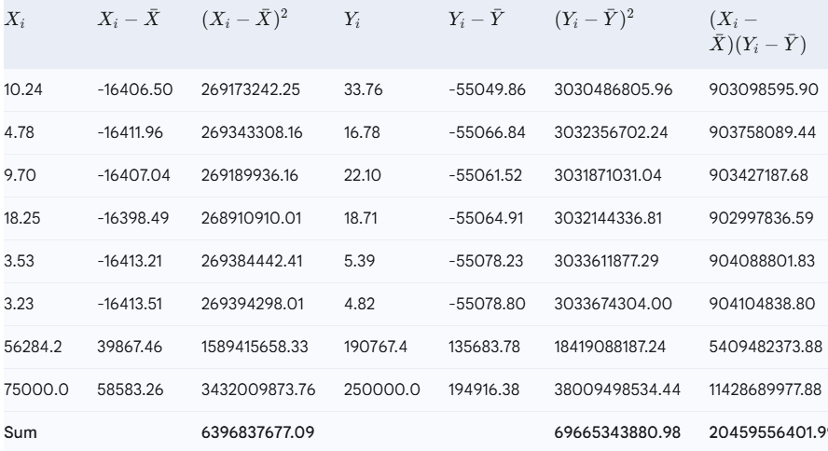**Table no. 4: showing calculation for correlation coefficient  
 **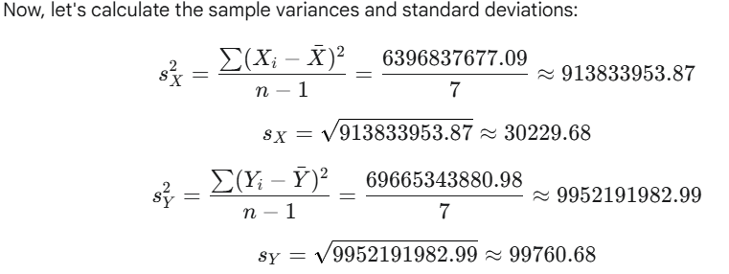  
  
**Now using the formula of correlation coefficient;  
**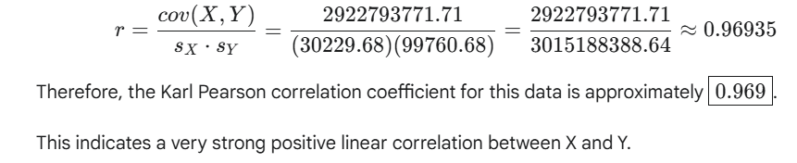  
  
Statistical significance of correlation coefficient:**It is necessary to check statistical significance of correlation coefficient to check whether the association is significant to infer about the association in population.Now  
  
**Null Hypothesis (H0​):** The population correlation coefficient (ρ) is zero. There is no linear relationship between X and Y in the population. (ρ=0)  
  
**Alternative Hypothesis (H1​):** The population correlation coefficient (ρ) is not zero. There is a linear relationship between X and Y in the population. (ρ=0) (This is a two-tailed test).

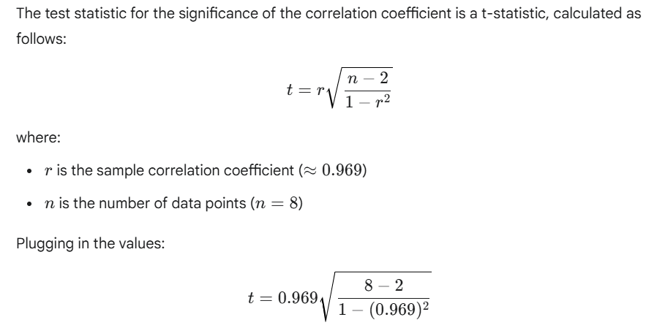  
 t = 9.607  
Since our calculated t-statistic (∣9.607∣) is greater than the critical t-value (2.447), Based on our hypothesis test, we reject the null hypothesis (H0​). This means there is statistically significant evidence to conclude that the population correlation coefficient (ρ) is not zero.  
  
**Quantification of relation between religion and economy using Regression analysis:**It is evident now that religion and economy are highly correlated in a positive way.Now assuming religion as an independent variable this research will try to quantify how change in religion affects the economy. This will be done assuming the extent of religion is directly proportional to state expenditure. So this study uses state expenditure as an independent variable for extent of religiosity. This study measures religion's effect on the economy by measuring state revenue for different state expenditure.As we discuss earlier in the study, taking state revenue as a dependent variable is relatively better than any other variable to measure economic effect. Also any revenue accumulated in the state treasury will only be used for welfare and development of the economy. So it is very much close to measuring economic effect and free from many extraneous effects.  
 Let's perform a linear regression of Y on X using the data. We want to find the equation of the form:   
 **Y^ = bo​+b​1X**where, b1​ is the slope and bo​ is the y-intercept.

We can calculate these coefficients using the following formulas:

**b1​= r*Sy​​/Sx**  & **bo = mean(Y) - b1*mean(X)**

We have already calculated the following values:

* Correlation coefficient (r) ≈0.969
* Mean of X ≈16416.74
* Mean of Y ≈55083.62
* Standard deviation of X (sX​) ≈ 30229.68
* Standard deviation of Y (sY​) ≈ 99760.68

Now, let's calculate b1​:

**b1** ​= 0.969×99760.68​/30229.68 ≈ 0.969×3.300 ≈ 3.1987

Now, let's calculate b0​:

**b0** ​= 55083.62−(3.1987×16416.74) ≈ 55083.62−52514.88 ≈ 2568.74

Therefore, the equation for the regression of Y on X is approximately:

**Y^ = 2568.74 + 3.1987X  
  
 Implications of the study:**  
 **1.** When government expenditure is zero i.e.X= 0 then expected state revenue is 2568.74. This tells that even if the government didn't spend a single penny it still generated revenue for the state. In terms of religion and economy it can be interpreted as even if there is no religion even then organization of such mega consuming events leads to plenty of treasury to state. This revenue generation is still there because there are fixed taxes levied on consumption.   
  
**2.** Differentiating the regression equation with respect to x so that we can understand how change in religiosity(state expenditure) leads to change in economy(state revenue)  
 **dy /dx = 3.1987**    
This suggests that for every unit increase in state expenditure, state revenue is expected to increase by approximately 3.1987 units. This can be termed as **Sensitivity of economic incentive to religious expenditure.** With our assumption of religiosity we can also see it as **sensitivity of economic incentive to religiosity   
  
3.** This study can have a huge implication in policy making, as it can give the government an approximate idea of how much the government will receive in return for their investment. The government can plan their budget accordingly.  
Now we know the regression equation just gives us a trend line i.e expected value of revenue for given value of state expenditure. There is a gap between actual revenue and expected revenue and this can be accounted for by incorporating error terms in the equation which result in a **sample** **regression function**.  
So,   
 **Yi = Y^ + ui** Where, Yi is actual value of state revenue  
 Y^ is deterministic relation between Y and X   
 and ui is a stochastic component or error term.  
This will help us in graphical representation of relationships using scatter diagrams.  
Fig 2.shows graphical relation:

**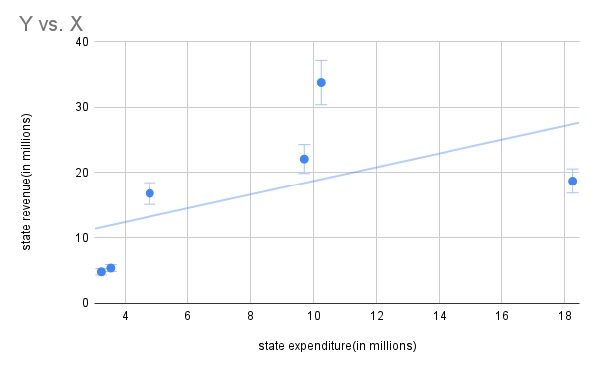  
 Fig 2.**Shows graphical relation between state revenue and state expenditure. **Limitations of the study:  
1. Lucas critique:** Lucas(1976) argues that it is naïve to try to predict the effects of a change in economic policy entirely on the basis of relationships observed in historical data, especially highly aggregated historical data.It holds that relationships between economic variables observed in past data or estimated by macro-econometric models are not reliable for economic policymaking because people rationally adjust their expectations and behavior based on their understanding of the impact of economic policy.  
  
**2.** **Constant rate of inflation:**This study is based on an assumed constant annual growth(inflation) rate of 5%. The actual future value could be higher or lower depending on the actual inflation rates experienced in India between years.The actual "future values"in 2025 would depend on the actual inflation rates experienced over the intervening periods.  
  
**3.** **Small sample size:** The sample size is very small. We know by law of large numbers, the more the sample size the better it represents the population.I have requested the data from the Cultural Department of Uttar Pradesh but to access the data i needed to go to the department and then only i can see archival records related to kumbh,But due to time and budget constraint i was not able to go there. The data used in this study is obtained from the Cultural Department camp at mahakumbh.  
  
**4. Presence of outliers:** There are some outliers due to which the model becomes **heteroscedastic** which then have bad consequences like independent variables become statistically insignificant.Also due to presence of outliers we are not able to draw the scatter plot for all the independent values of state expenditure as it is not possible to accommodate outliers with the other data. So we have omitted the outliers while plotting the scatter diagram  
  
**5. Measure of religiosity:** Assuming government expenditure as measure of extent of religiosity may not be a perfect choice as it is possible that government expenditure is highly affected by many other things like political or economic motives.Also there is no quantified relation between religiosity and government expenditure which prohibit us to interpret the result like how much change in religiosity will lead to change in   
  
  
  
  
  
  
  
  
  
  
  
  
  
  
  
  
  
  
**Mahakumbh and its varying impact**The Mahakumbh also presents a particularly interesting case study. As the world's largest religious gathering, it creates a temporary surge in economic activity. This surge can offer opportunities for income growth, but these opportunities are often unevenly distributed and may not address underlying issues of deprivation. This research delves into this dynamic, examining how the Mahakumbh affects the economic and capability deprivation of specific groups: rickshaw drivers, vendors, and artisans. However it is very important to differentiate deprived sections for our study.  
The research identifies individuals as marginalised if they are either socially marginalised or economically marginalised.Social marginalization refers to the exclusion of certain groups from mainstream social life, opportunities, and power structures based on their identity while Economic marginalization refers to the lack of access to economic resources, opportunities, and security, leading to poverty and vulnerability. Social marginalisation can be seen in form of  
**Social Exclusion and Violence:**They are disproportionately vulnerable to caste-based violence, abuse, and humiliation. Social norms often fail to provide them with equal protection under the law.  
**Social Stigma and Discrimination:**They are often stereotyped as "backward" or "primitive," leading to social exclusion and discrimination in interactions with the dominant society.   
Economic marginalisation can be seen in form of  
**Informal Sector Workers:** A large segment of the population, including many from marginalized social groups, works in the informal sector as daily wage laborers, street vendors, domestic workers, and in small-scale enterprises. They lack job security, social security benefits, and are vulnerable to exploitation and low wages.  
**Migrant Workers:** Often from economically backward regions and marginalized social groups, migrant workers face precarious working conditions, low wages, lack of social protection, and social exclusion in their destination areas.   
**Urban Poor:** Living in slums and informal settlements, the urban poor, often comprising migrants and marginalized social groups, face unemployment, underemployment, low wages, lack of basic amenities, and vulnerability to eviction.  
  
As evident in our research, the vendors and artisans rickshaw drivers are not only economically marginalized but also socially marginalised.In our study the derived section includes the participants who are either socially economically marginalised or can be both. The deprived section or marginalised section are mostly involved in informal sectors . In our study the informal sector is one which is not officially recognised by the government and one who doesn't pay any kind of rent for land acquired by them in kumbh. It must be noted that the Kumbh government has leased out land for mela period to different companies and people. These are registered vendors unlike vendors of the informal sector. In the informal sector most vendors carry their shops on *thela*. Some lay down their shops beside the road where they continuously moved back by the police. In this study we divide the informal sector into 6 major sectors namely Food and snacks, religious goods, rickshaw drivers, cosmetics and toys, water bottle for *amrit jal ,* and acrobats. data from 15 rickshaw drivers , 20 food vendors , 15 water container sellers, 15 sellers of religious goods and 3 & 2 respondents for cosmetic vendors and acrobats. The data for income of each respondent is averaged out and then used in study in the given manner.  
Below is the data related to their income per day before and in kumbh.

| Business tye | Income ( before kumbh) | Income (During kumbh) |
| --- | --- | --- |
| Rickshaw drivers | 911 | 1758 |
| Religious goods seller | 537 | 1412 |
| Food & Snacks | 1610 | 3275 |
| Cosmetics | 575 | 1694 |
| Plastic bottle seller | 956 | 2531 |
| Acrobats | 975 | 2500 |

**Table no 5:** showing income of various business before and after kumbh  
  
By looking at data we can see income in kumbh is much more than income before kumbh but to check whether this positive effect on income of deprived people is significant or not this study encompasses paired t tests.

Let μd represent the **mean difference** in income (After Kumbh − Before Kumbh) for informal sector workers.

* **Null Hypothesis (H₀):** μd≤0  
   *(There is no increase or a decrease in the income after the Kumbh Mela.)*
* **Alternative Hypothesis (H₁):** μd>0  
   *(There is a significant increase in income after the Kumbh Mela.)*

Applying paired t test formula ,  
 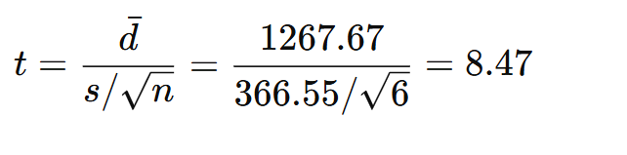  
Now degree of freedom= n-1=5  
Since we're testing if income increased, we use a one-tailed test.

So, p-value = 0.00019  
Since p-value (0.00019) < 0.10, we reject the null hypothesis.The data shows a statistically significant increase in income for informal sector workers after the Kumbh Mela, indicating that the event positively impacted their earnings.  
  
**Percentage Increase in Income of the Informal Sector (Overall)**

* Total Income Before Kumbh: ₹5,564
* Total Income After Kumbh: ₹13,170
* Percentage Increase: 136.70%

This means the income of informal sector workers more than **doubled** during the Kumbh Mela, highlighting a **136.7% rise** overall.  
  
**Sector-wise Analysis:**By looking at the data we can say there is overall increase as well as each and every section seeing an economic boost. But it must also be noted that there is a significant variance among percentage increase in income where some sectors see much higher increase in income while some comparatively less to others.This study also tried to find the reason behind this. The interview schedule used in the study has questions related to problems faced by the respondent that might explain the disparity between income increase and may also provide policymakers an idea for even better penetration of economic incentive for marginalized people involved in the informal sector.Data below describe the sector wise percentage increase in income per day.  
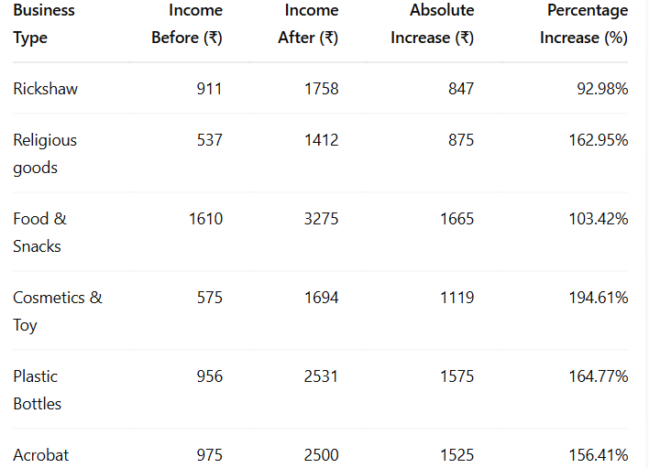  
 **Note:** This is average income per day   
**Table no 6**: showing percentage change in various business due to kumbh  
  
  
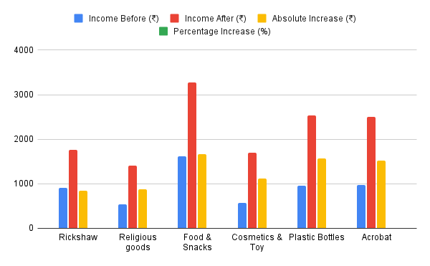  
**Fig no. 3**: showing column chart for above table:  
  
  
This column chart makes it easy to analyse the data and we can see almost all the types of marginalized sections have doubled their livelihood.  
  
**Let's discuss each sector one by one :**

#### **Religious Goods Sellers**

Increase: ₹875 (162.95%)

Inference: As the Kumbh Mela is primarily a religious event, devotional items like rudraksha, incense sticks, idols, etc. were in high demand. The sharp rise in income shows how spiritually motivated gatherings significantly benefit this sector. However, this increase is not only due to increase in demand but also the prices of religious goods have increased significantly .For a reference a standard basket of religious goods that cost around 20-25 rs in normal days is sold for 40-45 rs during kumbh. This standard basket only includes a matchstick, a sacred cloth(chunri), an incense stick, flowers and a camphor.  
Problems: As we discussed this is a very informal sector and has no officially allotted land for their shops so most of the shops are laid beside the road which lead to traffic on bathing days as well as normal days. Due to this they are forced by police to change their place many times.  
Solution : Government should also allocate lands to these shops as well at very low cost or free. This will also ensure stability for the seller and also reduce the problem of traffic.  
  
**Food & Snack Vendors**Increase: ₹1665 (103.42%)  
Inference: Food vendors more than doubled their income, catering to the constant flow of pilgrims. With people spending extended hours at the venue, food stalls become essential and highly profitable. Informal food stalls provide foods and snacks at a very low rate compared to the formal sector and most pilgrims belonging to middle class status prefer eating at these shops.it must be noted that not only the food vendors in mela kshetra has seen increase in revenue but vendors at bank road, railway station and other lace also see rise in their income per day.

Problems: The major problem reported by respondents was accidents that took place in mela kshetra. These accidents portray a bad picture for pilgrims who are planning to attend mahakumbh. Due to these accidents, the number of pilgrims declined. Respondent reported that there is a huge decline in revenue after the stampede on January 29. Also there were cases of mild fire at many places during kumbh.vendors believe that these accidents happen because some pilgrims lack civic sense .The vendors also said dusting affects their sales as pilgrims avoid eating outside due to dusting.  
Another major problem reported by vendors is diversion. Vendors told that due to diversion they don't face the expected demand due to which many times their product is spoiled.  
Solution: To solve this problem vendors suggested that authorities must sprinkle water after a regular time period so that dusting is reduced.  
  
**Cosmetic & Toy Sellers**

Increase: ₹1119 (194.61%) – Highest percentage increase

Inference: Despite not being essential, this sector showed the largest percentage gain. This suggests a notable presence of children and families, or tourists treating the event as both spiritual and recreational.The other reason may be that there were less number of shops of cosmetics and toys compared to other types of businesses and this leads to more increase in income of existing shop  
  
 **Acrobats**Increase: ₹1525 (156.41%)  
Inference: Street performers and acrobats benefited from crowd entertainment needs. Such performances are often traditional and attract attention, making this sector a vital part of cultural economy during the Mela.Major reason i can hypothesized is that people came at mahakumbh for spiritual purpose and they had a tendency to become more kind and more empathetic and this leads to donating money to the acrobats as acrobats are 10-12 year old girl who are risking their life to perform such stunts and pilgrims show empathetic behaviour.  
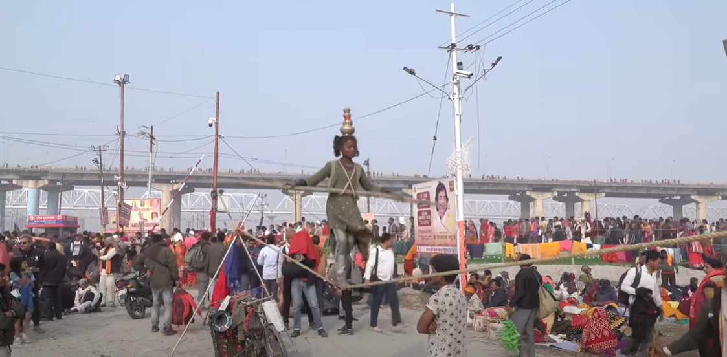  
**Plate no. 1:** A small acrobat entertaining pilgrims with her performance (by author) **Water container sellers**  
Increase: ₹1575 (164.77%)  
Inference: The seller of these water containers make a good amount of revenue not just in kumbh but even on normal days they are able to make around 1000 rs per day.This is result of spiritual significance of triveni sangam. Eole buys these small water containers to carry holy water to their home. During Kumbh their sales increased more than double.However, like in religious goods stores the prices are increased here too. The bottles which cost 20 rs on normal days are sold at 50 rs per day.  
Problem: They face similar problems like religious goods sellers. On bathing days or when there is traffic, they are forced by administration to resettle their shops somewhere else. There is also competition between the shops for placing their shops. There are incidents of fighting like if one seller lays their shop in front of another.Sellers also justify their rice increase of containers. They argued that due to sealing of the Prayagraj border there was a steep decline in supply of bottles due to which their prices increased.  
Solution: there is much requirement of land allocation for the informal sector as well. The supply chain issue arose after the stampede on january 29th when the government sealed the border of prayagraj. This issue is not just faced by these sellers but each and every type of sellers in prayagraj are affected due to it so authorities must focus on how to avoid supply chain issues.  
  
**Rickshaw Drivers  
Increase:** ₹847 (92.98%)  
Inference: Rickshaw drivers saw a substantial increase in income, almost doubling their daily earnings. This is likely due to high footfall, increased mobility within the Mela area, and restricted vehicular movement—making rickshaws a primary mode of local transport.  
Problems: the major problem faced by rickshaw drivers is diversion and prohibited entry. Authorities have prohibited the entry of three or four wheeler vehicles at many areas to avoid traffic.Due to this rickshaw drivers were not able to make as much income as they expected. Also rickshaws were carrying more than their capacity which might be very harmful for the pilgrims. Rickshaw drivers were also complaining about the two wheeler transport system that has originated in kumbh. As these two wheelers are allowed to places which were prohibited for rickshaws so taking away their passengers.  
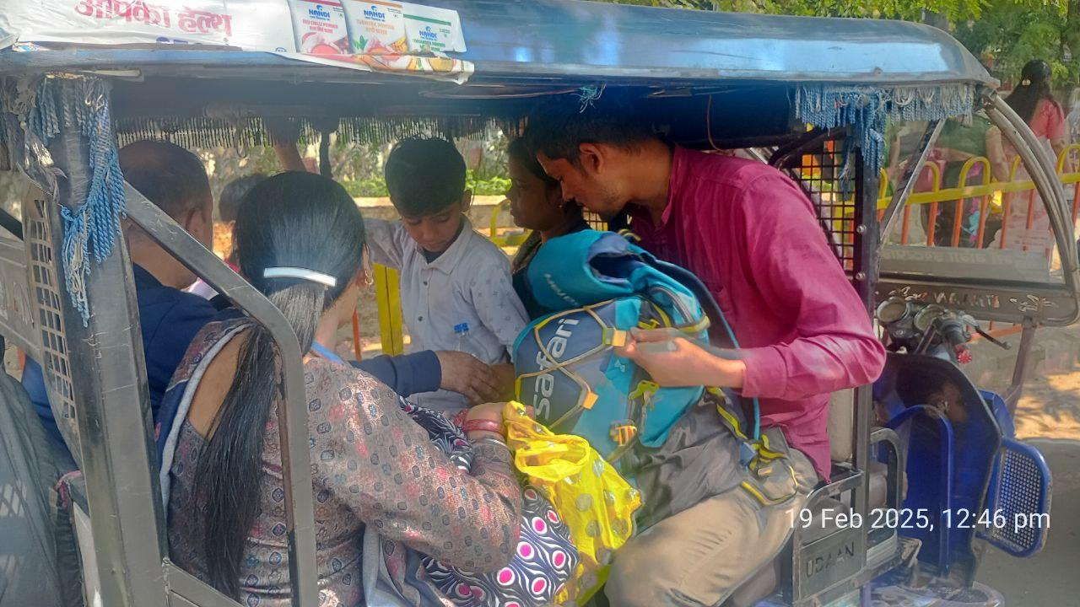  
**Plate no. 2 :** A rickshaw at *bank road* carrying more than its capacity (by author)  
  
 Solution: Government must tighten the traffic rules so any kind of big and small accident can be prevented.  
  
  
**Comparison between informal and formal sector**Formal sector mainly compasses of vendors who are not deprived either socially or economically unlike informal sector. It will be very interesting to see how this mega event affects the formal sector. Whether it has induced more economic boost for the formal sector or less as compared to the formal sector.   
For this we compare the income of food vendors and how it is increased in kumbh with the percentage increase in income of food vendors of the informal sector.Total number of formal vendors in kumbh as per the official data is 7000. These vendors have acquitted land by following legal procedure and they will pay rent as well as taxes to the government.For the formal sector majority of the data is collected form Arail side as there is more VIP movement and many food and beverages industry giants like dominos, pizza hut have their outlet at Arail side so it will give more clear picture of disparity between informal(marginalised) and formal vendors. The sample size for this will be 25 for level of significance at 10% and fro 10% of the population.This study average out the income of same type of food vendors like dominos and pizza hut, amul and namaste india etc. so that more accurate can be assured for data related to income. The data of income per day before and after kumbh started for formal food and snake vendors is given below:  
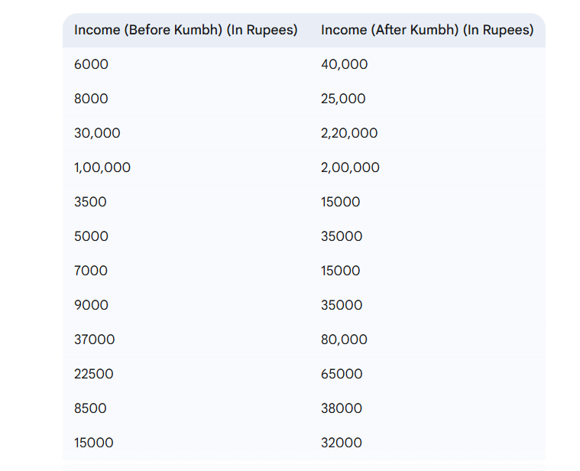  
 **Table no 7:** showing income of formal sector before and after kumbh  
  
Here also it is very evident that mahakumbh has led to significant increase in income of the formal sector food vendors but we have to check whether this effect of mahakumbh is significant or not. So we will employ one tailed paired t test at a level of significance of 10% again. Now,   
  
**Null Hypothesis (H0​):** There is no significant increase in income after the Kumbh Mela, or income has decreased or stayed the same. Mathematically, μd​≤0  
  
**Alternate Hypothesis (H1​):** There is a significant increase in income after the Kumbh Mela. Mathematically, μd​>0

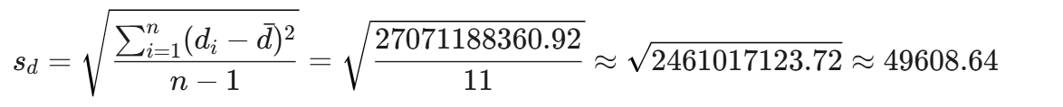

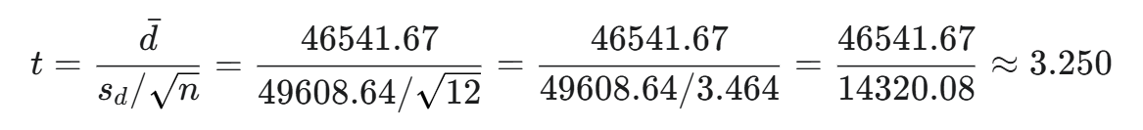  
Now at significance level, 0.10 abs( tcalculated ) >abs(ttabular)  
  
So we can infer there is statistically significant evidence to suggest that the Kumbh Mela had a significant effect( increases) on income for the formal sector .  
  
Now let's calculate the percentage increase in income of formal sector food vendors:  
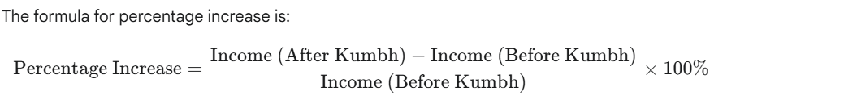  
 Using this percentage increase = 202.19%.  
  
Here we can see the percentage increase in revenue of food vendors of the informal sector is significantly lower(103.42%) as compared to the formal sector is 202.19%.Based on this we can interpret something:  
  
**1.** Formal sector is milking much more revenue than the informal sector both in absolute terms and percentage wise. No doubt that marginalised people engaged in the informal sector have milked Kumbh very well but they still lag behind the formal sector which will widen the income gap.

**2.** Consumerism in religion: the increase in the food and beverage sector is very obvious as Pilgrims, while undertaking a spiritual journey, are also consumers requiring these basic amenities but increase in the formal sector where prices are so high and consumption of those things are not necessities gives a hint of consumerism in religion.  
  
**3.** One must remember that this increase in income is not just due to increase in demand because of pilgrims but also due to increase of prices by sellers.Each and every type of businesses has increased the price to lead their gains to the highest level. For example, I have bought a mineral water bottle for 25 rs even when MRP is 10 rs only. Government and authorities must take strict action so that this plunder by vendors both formal and informal must stop and the religious center doesn't become a place of plunder of pilgrims.  
  
4. One thing is very important to notice that these food industry giants like Dominos don't offer all the snacks and variety of snacks which they serve in their regular outlet, mainly economical packages. After interrogation , I got to know that they are doing this so that it can be afforded by a major portion of pilgrims and more revenue generation is possible.  
  
**Limitations:**1. The data provided by respondents may not be accurate. Income is a very sensitive topic and many sellers due to fear of authorities are hesitant to give their actual data . Averaging has been done to ensure better accuracy but there's still a chance of some not totally correct data.

2. The sample size could have been more. As we are commenting on such a big economic system we should have collected data from more vendors so that our results are more valid and reliable.

3. Anomalous case of Dominos:   
While interviewing a dominos employee in sector 6 i got to know that everything is not going good for dominos in kumbh. Dominos has a total of 4 outlets in the whole mela kshetra. As reported by the employee Dominos is only able to make 70,000 to 80,000 per day in sector 6 while it is making around 2,00,000 per day in outlets of Parade ground and Arail. Domino's employees said that on normal days their outlet is making around 1,30,000 per day in the outlet of civil lines. So the dominos is suffering a significant loss in sector 6. The reason told by the employee is the weather and dusty environment for low sales. Due to excessive dust, people avoid eating outside. They argued that the government failed to address this issue by not sprinkling enough water on the roads to control dust.They also argue due to limited VIP movement and footfall they were only able to make about ₹70,000 per day—significantly less than expected.  
The objective of this study does not concern these exceptions and it might ignore these unexpected results.  
4. This study only compares data of the food and beverage industry in the formal sector but there are many other industries like transport( buses/ railways/ flights) , Accommodation. This study doesn't talk about this part of the formal sector.  
   
  
  
   
  
  
  
  
  
  
  
  
  
  
  
  
**Conclusion**The Maha Kumbh Mela 2025 in Prayagraj exemplifies the profound interconnection between religion and economy. As the world’s largest religious congregation, it functions not only as a spiritual gathering but as a temporary economic ecosystem that engages millions—particularly those in the informal sector. This dissertation has aimed to critically examine how this grand religious festival influences economic outcomes for marginalized groups, including rickshaw drivers, street vendors, sellers of religious goods, and others. Through a combination of fieldwork, interviews, statistical analysis, and anthropological theory, this study has uncovered the dual role of religion as both a cultural force and an economic engine.  
Religious festivals such as the Kumbh Mela do not exist in isolation from broader socio-economic contexts. Instead, they actively shape and are shaped by them. As Emile Durkheim (1912) pointed out, religion fosters social cohesion, and in the Indian context, it simultaneously activates economic networks, especially during massive events like the Kumbh. The empirical findings from this study support the bidirectional relationship proposed by scholars like McCleary and Barro (2003, 2006), who argue that economic conditions influence religiosity and that religious values in turn shape economic behavior. The positive correlation observed between state expenditure and state revenue during the Kumbh—validated through regression analysis—further demonstrates that investment in religious infrastructure yields significant economic returns.

One of the most striking findings of this study is the substantial rise in the income of informal sector workers during the Kumbh. On average, their income increased by approximately 136.7%, a figure derived through paired t-tests across six categories: food vendors, religious goods sellers, water container sellers, toy vendors, acrobats, and rickshaw drivers. Each group reported statistically significant income gains, with the highest percentage increase seen among cosmetic and toy sellers (194.61%), followed by water bottle sellers (164.77%) and religious goods vendors (162.95%). This increase was not just due to heightened demand, but also due to opportunistic price hikes—a phenomenon visible across sectors. For example, a water bottle with an MRP of ₹10 was being sold for ₹25, and religious baskets costing ₹25 on regular days were sold for ₹45 during the Kumbh.  
Despite these positive outcomes, the data reveals a stark disparity between the informal and formal sectors. While informal vendors experienced notable growth, formal vendors, including food and beverage giants like Domino’s and Amul, saw an even greater rise—an average of 202.19% in income. This disparity underlines systemic inequalities in how different groups benefit from the same event. Formal vendors enjoy legal protections, allocated spaces, and infrastructural support, while informal vendors often face harassment, lack of stable locations, and poor sanitary conditions. Many informal vendors reported being repeatedly displaced by authorities or struggling due to traffic diversions and limited access to customers. These challenges underscore the need for policy interventions that aim to provide legal recognition and spatial inclusion to informal workers during such mega-events.  
The transport sector also experienced a surge in entrepreneurial activity. The study documented cases where local youth earned between ₹3,000 and ₹5,000 daily by ferrying pilgrims on two-wheelers—creating a parallel, unregulated transport service. Similarly, handcart pullers (thela-walas), many of whom were previously wage laborers, shifted to passenger transport services during the Kumbh, renting carts for ₹200–₹300 a day and earning up to ₹250 per ride. However, these practices raised safety concerns, as overloading and lack of regulation created risks for both operators and pilgrims. These cases illustrate how religious tourism fosters temporary micro-enterprises, although often within unregulated and vulnerable frameworks.  
While economic data from the Kumbh clearly supports the hypothesis that religion can fuel economic growth, the findings also point to ethical and structural dilemmas. Price gouging, inequality in benefits, exploitation of landless vendors, and neglect of public health standards question the fairness of the religious economy. Furthermore, the regression analysis revealed that for every additional unit of state expenditure, revenue increased by approximately 3.2 units. Although promising, this result must be interpreted cautiously. As Lucas (1976) warned in his critique of econometric policy models, historical data cannot always reliably predict future outcomes, especially when participants alter their behavior in response to policy changes.

On a theoretical level, this dissertation contributes to the ongoing academic conversation about the secularization hypothesis. Contrary to the claim that modernization leads to the decline of religiosity, the increasing scale of the Kumbh suggests that religious events can thrive even in modern, rapidly urbanizing societies. As Casanova (1994) argues, modernity and religion are not mutually exclusive; rather, religion adapts, survives, and often flourishes in the modern world. The Maha Kumbh, therefore, challenges the secularization thesis and presents an alternative model where tradition coexists with capitalism and modern infrastructure.

In summary, the Kumbh Mela is more than a spiritual phenomenon—it is a multi-dimensional event that activates economic networks, reshapes local labor markets, and offers profound insights into how sacredness intersects with capitalism. While it has proven to be a lifeline for many informal workers, the event’s benefits are unevenly distributed, revealing deep-rooted inequalities that must be addressed through inclusive policy-making. This study reinforces the view that religious festivals like the Maha Kumbh offer not only cultural enrichment but also opportunities for economic empowerment, particularly for those on the margins. However, these opportunities will remain partial and precarious unless there is a concerted effort to make economic participation more inclusive, dignified, and secure.  
  
  
  
  
 **References**  
- Singh,Prakash(ed). 2022.” *Prayagraj Kumbh: A Multi-Dimensional Study of the Greatest Spectacle on Earth”,*Macmillan education.*115-116*.  
  
- Weber, M. (2002).” *The Protestant ethic and the spirit of capitalism”* (S. Kalberg, Trans.). Roxbury Publishing Company*.49-52*.  
  
**-**Samuelson,PA.1954,”The pure theory of public expenditure”.*The Review of Economics and Statistics 36(4) 387-389.***-** McCleary,Rachel.2007,“Salvation, Damnation, and Economic Incentives”. *Journal of Contemporary Religion 22(1)*.*49-74.*

- McCleary,Rachel.2011.“The Economics of Religion as a Field of Inquiry”.In *The Oxford Handbook of the Economics of Religion*” edited by Rachel McCleary. Oxford: Oxford University Press,3-36.  
  
-Srivastava,Sanatan and Rai,Ajeet.2014.”Socio–Economic Dimension of Kumbh Mela 2013 and the organizational aspect of it: A Study”.*International Journal Of Management 5(5),25-32*.  
  
-Baro,Robert & McCleary,Rachel.2006.”Religion and Economy”.*The Journal of Economic Perspective*.20(2).49-72.

-Carrier,James(ed).2005.”*A Handbook of Economic Anthropology*.” Massachusetts: Edward Elgar Publishing.*112-363.*  
  
-<https://www.moneycontrol.com>/  
-<https://www.businesstoday.in/>  **-** [www.kumbh.gov.in](http://www.kumbh.gov.in)  **-** [www.pib.gov.in](http://www.pib.gov.in)   
- [https://theprint.in](https://theprint.in/)/